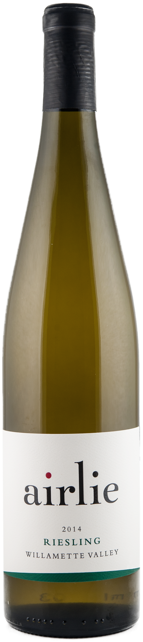

2014 riesling

**Awards: Gold – Cascadia Wine Competition - 2016**

**Tasting Notes:**

Versatility is one of the reasons our winemaker, Elizabeth Clark, adores Riesling. Drier in style, our Riesling balances bright acidity with a hint of sweetness. Enjoy this wine with food but also sipping on the veranda with friends.

**Winemaking Notes:**

The grapes were hand harvested and immediately pressed off to minimize skin contact. Pressing decisions are done by taste and the cycle was stopped at just over one bar of pressure in order to minimize potential phenolics. Each vineyard was treated separately, and after settling, inoculated with different yeasts. Fermentation temperatures were kept at 52° to 55°F and lasted about six weeks until the wines tasted balanced. The wine was blended in early January and after cold stabilizing and filtering the wine was bottled in January 2105.

**Harvest Notes:**

The 2014 growing season was the warmest on record for the Willamette Valley, until 2015. Our cooler estate vineyard on the edge of the Oregon Coast Range welcomed the steady warmer temperatures rather than a blistering heat wave at the end of the season. The extra warmth led to early sugar accumulation followed by light rain prior to harvest. This slowed ripening just enough to allow full flavor development producing a well-balanced grape, perfect for making wine.

Our winery and vineyards are certified sustainable by Salmon Safe and LIVE. The vineyards are hand cultivated allowing us to respond to individual vine needs.

|  |  |
| --- | --- |
| **Wine Information:**  **Alcohol:** 12.4%  **pH**: 2.95  **Titratable Acidity**: 8.3 g/L  **Residual Sugar**: 1.1%  **Malolactic**: No  A**ging:** Stainless Steel  **Number of Cases:** 1,681 | **Harvest Information:**  **Appellation:** Willamette Valley  **Vineyard Sources:**   * Dunn Forest planted 1983 (22%) * BeckenRidge planted 1978 (78%)   **Harvest Dates:**   * Dunn Forest: Oct 13th * BeckenRidge: Oct 13th   **Sugar**: 21O Brix  **pH**: 3.0  **Titratable Acidity:** 8.7 g/L |