2015 chardonnay
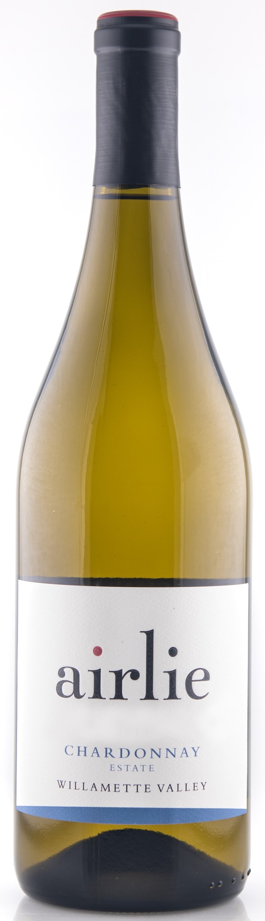
SILVER – San Francisco Chronicle 2020

Tasting Notes:
Our estate vineyard, Dunn Forest, was a pioneer in Oregon’s first plantings of the Dijon Clone Chardonnay, ideal in our cool climate. We ferment our Chardonnay in mostly neutral oak barrels, which highlight notes of apple pie and butterscotch making this a food friendly gem. A vibrant array of citrus notes along with tropical flavors and touches of apple and melon will have you pairing this wine with dishes topped with cream sauces, pesto or mango salsa.

Winemaking Notes:
The fruit was gently de-stemmed directly into the press to minimize skin contact. Pressing decisions were done by taste and the press was stopped at just one bar of pressure to minimize the potential development of phenolics. After three days of settling, the juice was racked off its lees and sent to barrel. We inoculated with ten yeasts, two barrels of each, to increase complexity and after primary fermentation, the barrels were then inoculated for malo-lactic (ML). During ML, the barrels were stirred twice a week to increase mouthfeel and roundness. After ML, the wine was sulfured and allowed to sit on its lees, again adding to mouthfeel and to develop further complexity. The wine was racked to tank in the end of August, cold stabilized, filtered and bottled in September 2016.

Harvest Notes:
The 2015 growing season is now the warmest on record for the Willamette Valley. The prolonged heat posed some real challenges for this vintage. Initially we thought we would have a surplus of grapes but as the 100+ degree days persisted, our concerns were that the higher temps may yield fruit that lacked acidity. Prolonged higher temps can also produce higher alcohol content due to the increase in sugar. We chose harvest dates carefully and avoided those issues.

Our winery and vineyard is LIVE certified sustainable and Salmon Safe. The vineyard is hand cultivated allowing us to respond to individual vine needs.

Wine Information:  Alcohol: 13.1%  pH: 3.89  Titratable Acidity: 5.5 g/L  Malolactic: Yes  Barrel Aging: 10 months  Cooperage: 5% new American oak  Number of Cases: 552 | Harvest Information:  Appellation: Willamette Valley  Clones: Dijon  Vineyard Source: Dunn Forest (Estate) planted 1991  Harvest Date: Dunn Forest: Oct. 3rd  Sugar: 21.4^{O} Brix  pH: 3.65  Titratable Acidity: 8.3 g/L

